WB-0FC-2N/O
2.4 Ghz 300 Mbps 1 KM Wireless Bridge

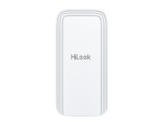

The wireless bridge can be applied in industries, such as wireless video security, railway, transportation, power and other industries, wireless video/data transmission, wireless coverage, carrier wireless backbone network construction, Wi-Fi wireless coverage, rural information construction, and wireless network coverage. The long-distance transmission of the device can guarantee multi-channel HD video transmission.

- Up to 1 km wireless transmission distance
- 300 Mbps 802.11n wireless bridge
- Built-in 7dBi 2 × 2 MIMO antenna
- Visualized topology management
- Real-Time alarm push technology

- Specification
Wireless Parameter
Max. Transmission Rate of Air Interface | ≤ 300 Mbps
Wireless Standard | IEEE 802.11b/g/n (2 × 2 MIMO 300 Mbps)
Working Frequency Band | 2400 MHz ~ 2483.5 MHz
Receiving Sensitivity | -87±2 dBm @HT40 MCS0
Antenna Gain | 7 dBi
Antenna Angle | (H) Beamwidth [3 dB] 35° (V) Beamwidth [3 dB] 35°
Transmitting Power | 23 dBm @11n MCS0 (Note: Transmitting power may vary with local regulations.)
Throughput Rate | PTP:  90 Mbps/0.2 KM(HT40),  75 Mbps/0.5 KM(HT40),  40 Mbps/1 KM(HT40)  PTMP(1 to 4):  20 Mbps/1 KM(HT40)
Hardware Parameter
Network Interface | 2 × 10/100 Mbps RJ45 ports
LED Indicator | Power indicator, LAN indicator, Signal intensity indicator
Reset | Hardware resetting button
Power Supply | 12-24 VDC Passive PoE
Software Function
Application Function | TDMA, DFS, TPC, IFM, IPM
Channel Width | 10/20/40 MHz
Channel Selection | Auto/manual selection
Network Protocol | NTP (network time synchronization), SADP (auto search for IP address), HTTPS (web management), SSH (debugging)
Security Mode | WPA2-PSK
Security Mechanism | Wireless network name hidden
Management Method | Web
Upgrade | Web
System Log | Syslog, Control center information
General
Product Dimensions (W × H × D) | 81 mm × 52 mm × 165 mm (3.62'' × 2.28'' × 7.36'')
Package Dimensions (W × H × D) | 132 mm × 228 mm × 91 mm (5.19" × 8.97" × 3.58")
Net Weight | 0.19 kg (0.42 lb)
Gross Weight | 0.49 kg (1.08 lb)
Packing List | Wireless Bridge × 1, Power Adapter (12 VDC, 1 A) × 1, 10/100 Mbps PoE Injector × 1, Binding Tape × 2, Quick Start Guide ×1, Regulatory Compliance and Safety Information × 1

Packing Method | Single unit packing
Working Temperature | -30 °C to 70 °C (-22 °F to 158 °F)
Working Humidity | 5% to 95% (no condensation)
Storage Temperature | -40 °C to 80 °C (-40 °F to 176 °F)
Storage Humidity | 5% to 95% (no condensation)
Installation Mode | Pole Mounting
Ingress Protection | IP55
Power Consumption | 1.8 W for typical (1-ch 2MP IPC), Max. 4.5 W
Approval
EMC | CE-EMC (EN 55032: 2015+A11: 2020, EN IEC 61000-3-2: 2019, EN 61000-3-3: 2013+A1: 2019, EN 50130-4: 2011+A1: 2014, EN 55035: 2017+A11: 2020)
Safety | CB (AMD1:2009, AMD2:2013, IEC 62368-1: 2014 (Second Edition)), CE-LVD (EN 62368-1: 2014+A11: 2017), UL (UL 60950-1)
Chemistry | CE-RoHS (2011/65/EU), WEEE (2012/19/EU), Reach (Regulation (EC) No.1907/2006)
Radio | EN 301 893, EN 300 440, EN 62311, EN 301 489-3, EN 301 489-17

- Typical Application
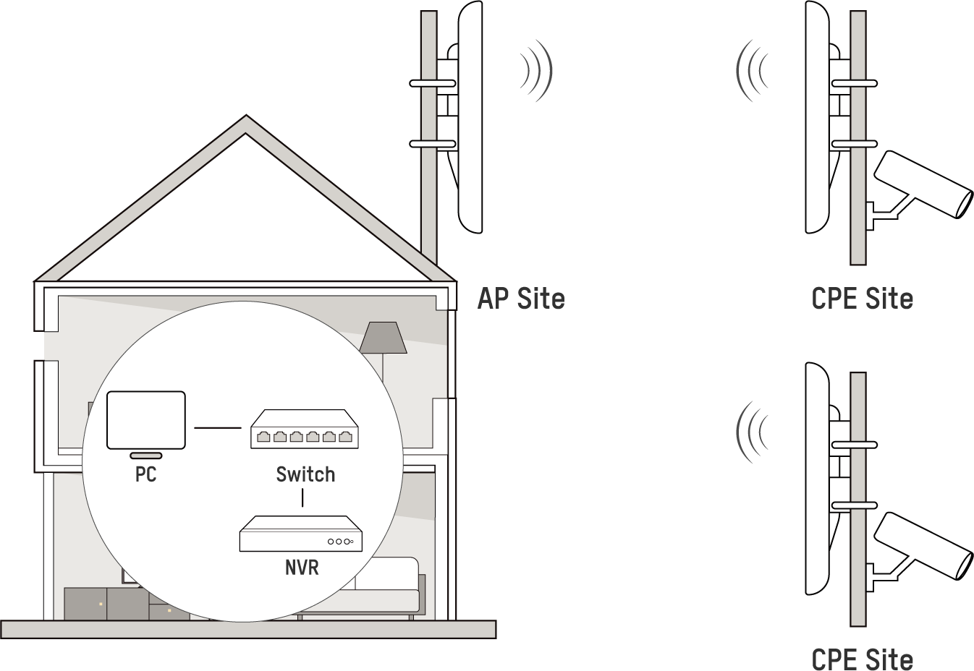

- Physical Interface
No. | Interface/Button | Description
1 | Reset | Long press for 4 seconds to restore to factory settings.
2 | PoE/LAN 1 | The 10/100 Mbps adaptive RJ45 port, also can be used as a PoE port.
3 | LAN 2 | The 10/100 Mbps adaptive RJ45 port.
4/5 | Network Cable Slot | Reserved for easy placement of the network cables.
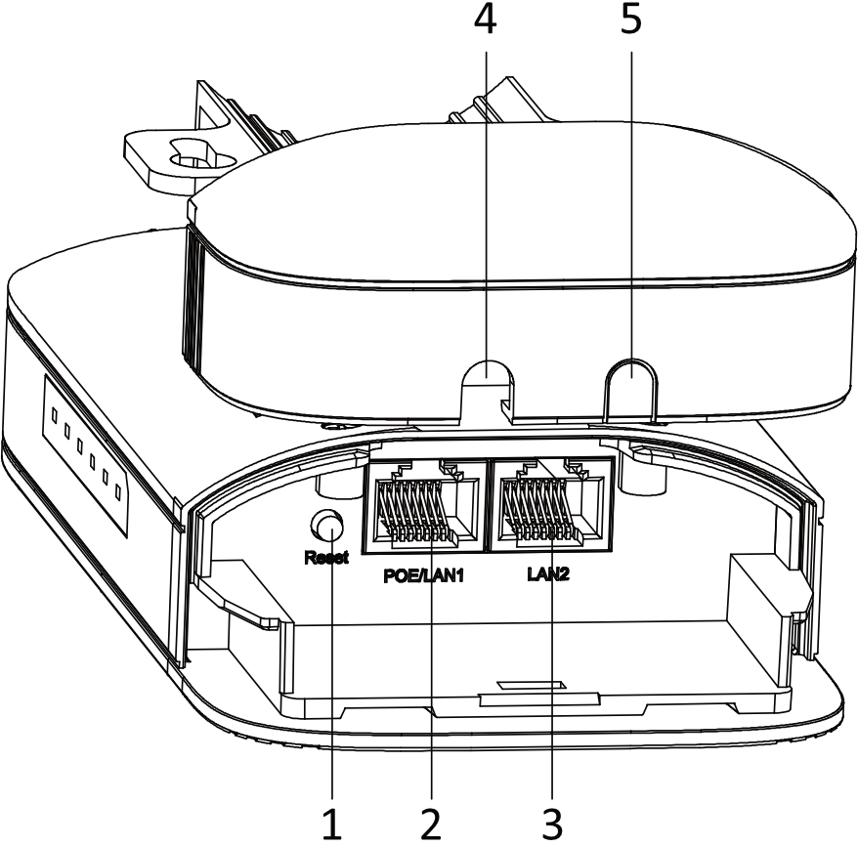

- Available Model
WB-0FC-2N/O

- Dimension
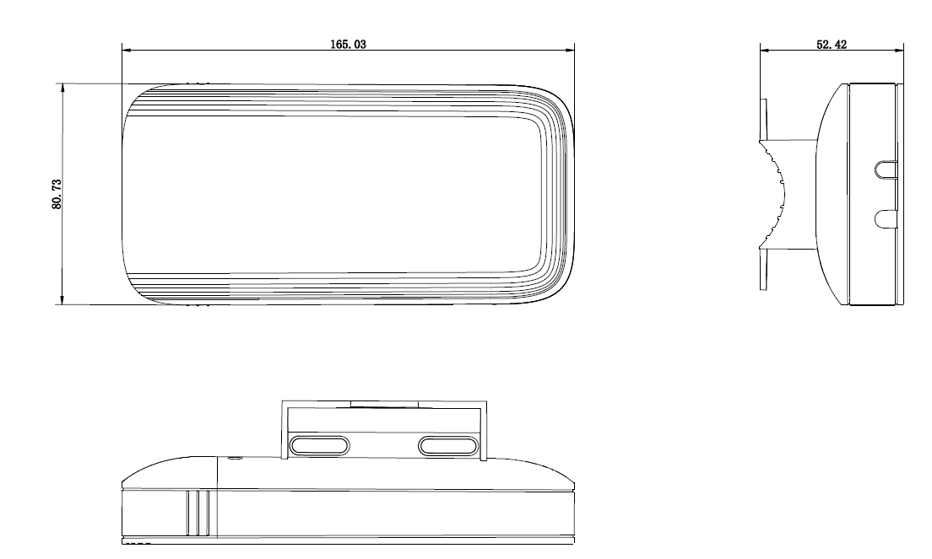
Unit: mm

